koordinat 39.91537323332108, 32.82036872471701

<https://osmcompass.com/>

[google maps link](https://www.google.com/maps/place/39°54'55.3"N+32°49'13.3"E/@39.9153861,32.819439,18.17z/data=!4m4!3m3!8m2!3d39.9153732!4d32.8203687)

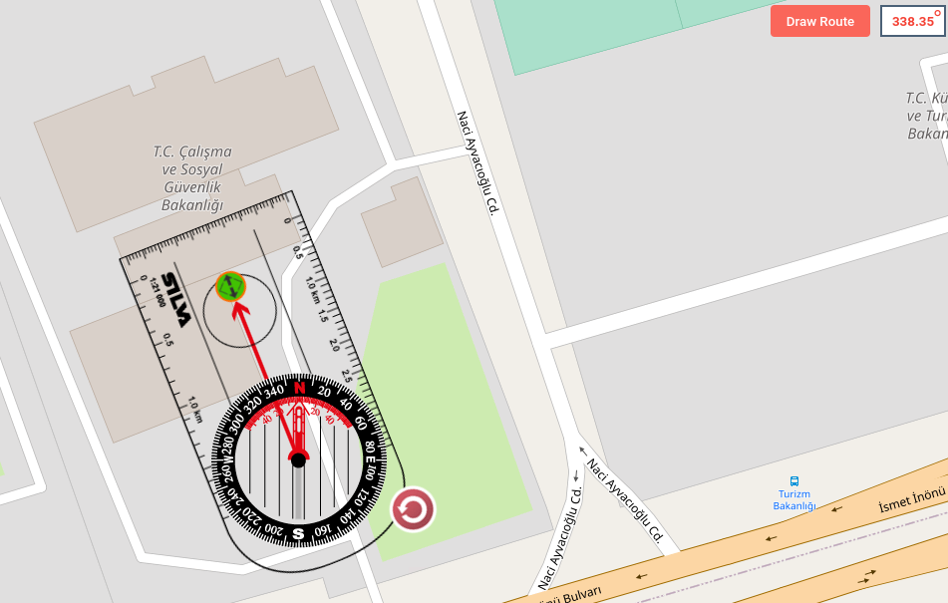-----

Bakanlık azimut açısı = 338-360 = **- 32 mi ???**

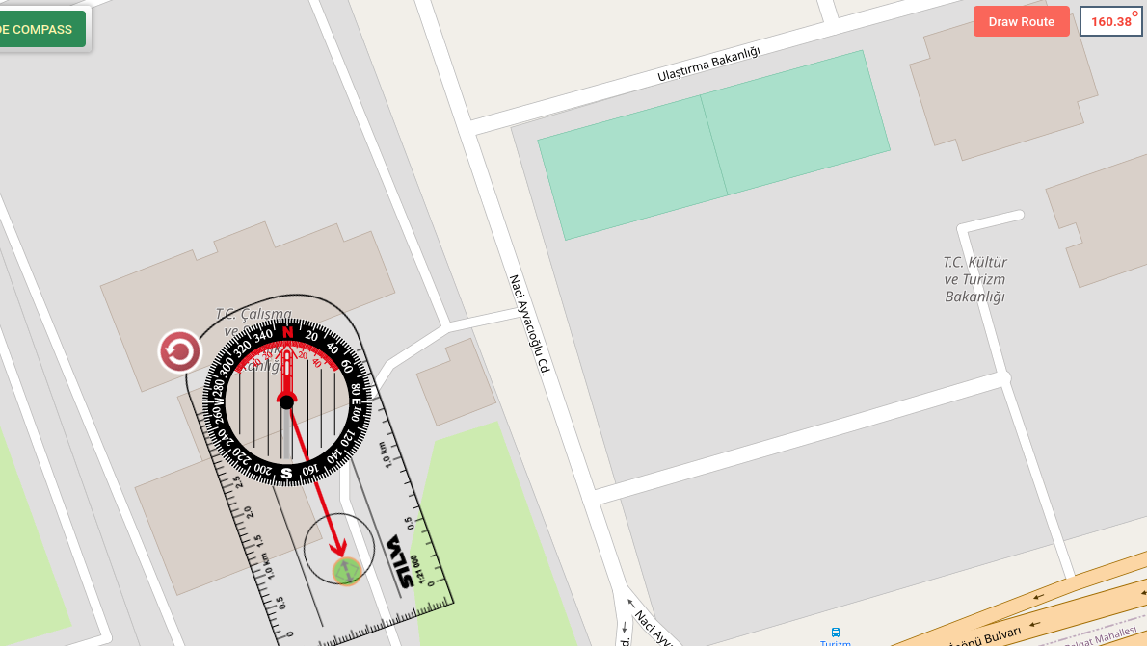**-----**

**https://pvwatts.nrel.gov/pvwatts.php**

|  |  |  |
| --- | --- | --- |
| Month | Solar Radiation  ( kWh / m2 / day ) | AC Energy  ( kWh ) |
| January | 1.94 | 2,026 |
| February | 3.14 | 2,929 |
| March | 3.58 | 3,655 |
| April | 4.45 | 4,267 |
| May | 5.47 | 5,260 |
| June | 6.45 | 5,910 |
| July | 7.16 | 6,713 |
| August | 6.76 | 6,381 |
| September | 5.89 | 5,452 |
| October | 3.59 | 3,556 |
| November | 2.23 | 2,209 |
| December | 1.38 | 1,414 |
| Annual | 4.34 | 49,772 |

|  |  |
| --- | --- |
| Location and Station Identification | |
| Requested Location | 39.91540018456091, 32.82043013863253 |
| Weather Data Source | (INTL) ANKARA, TURKEY 16 mi |
| Latitude | 40.12° N |
| Longitude | 32.98° E |
| PV System Specifications | |
| DC System Size | 40.0 kW |
| Module Type | Standard |
| Array Type | Fixed (open rack) |
| System Losses | 14.08% |
| Array Tilt | 20° |
| Array Azimuth | 160° |
| DC to AC Size Ratio | 1.2 |
| Inverter Efficiency | 96% |
| Ground Coverage Ratio | 0.4% |
| Albedo | From weather file |
| Bifacial | No (0) |
| Monthly Irradiance Loss   |  |  |  |  |  |  |  |  |  |  |  |  | | --- | --- | --- | --- | --- | --- | --- | --- | --- | --- | --- | --- | | Jan | Feb | Mar | Apr | May | June | July | Aug | Sept | Oct | Nov | Dec | | 0% | 0% | 0% | 0% | 0% | 0% | 0% | 0% | 0% | 0% | 0% | 0% | |  |
| Performance Metrics | |
| DC Capacity Factor | 14.2% |

